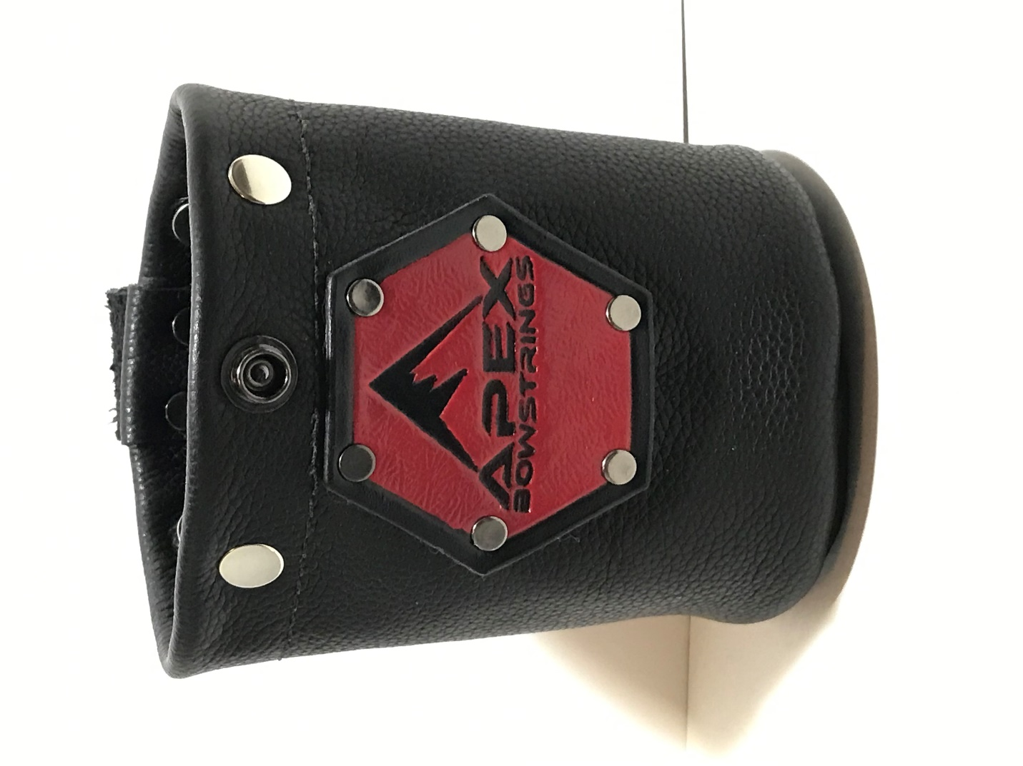

Step 6

Step 3&6

Step 2&5

Step 4

Step 1

|  |  |  |  |
| --- | --- | --- | --- |
| ***Step 1*** | **Choose Color of Chap Leather** | [Search results for "midweight chap" (springfieldleather.com)](https://www.springfieldleather.com/search?keywords=midweight%20chap&page=1) | Choose an item. |
| ***Step 2*** | **Choose main design** | **Basket Weave Stamps** | **Choose an item.** |
|  |  | **Background Stamps** | **Choose an item.** |
| ***Step 3*** | **Choose boarder-edge design** | **Boarder-Edge Stamps** | **Choose an item.** |
| ***Step 4*** | **Choose Name or Initials** | **Initials, Name** | **Click or tap here to enter text.** |
| **Name and Number Stamps** | **Choose an item.** |
|  |  | **African Animals** | **Choose an item.** |
|  |  | **Arrow** | **Choose an item.** |
|  |  | **Bears** | **Choose an item.** |
|  |  | **Bighorn** | **Choose an item.** |
|  |  | **Birds** | **Choose an item.** |
|  |  | **Bison** | **Choose an item.** |
|  |  | **Coyote Wolf** | **Choose an item.** |
|  |  | **Deer** | **Choose an item.** |
|  |  | **Elk** | **Choose an item.** |
|  |  | **Fish** | **Choose an item.** |
|  |  | **Moose** | **Choose an item.** |
|  |  | **Mountain Goat** | **Choose an item.** |
|  |  | **Small Animals** | **Choose an item.** |
|  |  | **Snake** | **Choose an item.** |
|  |  | **Wild Cats** | **Choose an item.** |
|  |  | **Custom Design** | **Click or tap here to enter text.** |
|  |  | **Other Stamps** | **Choose an item.** |
| ***Step 5*** | **Choose the main color** | **Fiebing’s Professional Oil Dye** | **Choose an item.** |
| **Fiebing’s Leather Dye** | **Choose an item.** |
| **Fiebing’s Antique Leather Stain** | **Choose an item.** |
| **Fiebing’s Vintage Gel** | **Choose an item.** |
| **Angelus Leather Acrylic Paint** | **Choose an item.** |
| **Angelus Leather Dye** | **Choose an item.** |
| **Angelus Metallic Leather Paint** | **Choose an item.** |
| **Angelus Pearlescent Leather Paint** | **Choose an item.** |
| **Angelus Neon Acrylic Paint** | **Choose an item.** |
| **Angelus Collector Edition** | **Choose an item.** |
| ***Step 6*** | **Choose color of boarder** | **Fiebing’s Professional Oil Dye** | **Choose an item.** |
| **Fiebing’s Leather Dye** | **Choose an item.** |
| **Fiebing’s Antique Leather Stain** | **Choose an item.** |
| **Fiebing’s Vintage Gel** | **Choose an item.** |
| **Angelus Leather Acrylic Paint** | **Choose an item.** |
| **Angelus Leather Dye** | **Choose an item.** |
| **Angelus Metallic Leather Paint** | **Choose an item.** |
| **Angelus Pearlescent Leather Paint** | **Choose an item.** |
| **Angelus Neon Acrylic Paint** | **Choose an item.** |
| **Angelus Collector Edition** | **Choose an item.** |
| **Angelus Glow in Dark Paint** | **Green Grow** |
| ***Step 7*** | **Name** | **Click or tap here to enter text.** | |
|  | **Address** | **Click or tap here to enter text.** | |
|  | **Phone** | **Click or tap here to enter text.** | |
| ***Step 8*** | **Notes:**  **Let me know your thoughts!**  **If you have Company Logo, I can get a leather stamp made. (Extra Cost) But it can be use over and over.**  **Let me know if you want a custom scene.** | **Click or tap here to enter text.** | |